2. Introduction / Background
The biological question I aim to address is the following: How conserved are the catalytic domains and residues of SPR-5 (C. elegans) and KDM1A (human), and does this conservation support the use of C. elegans as a model for studying KDM1A-linked fertility and development?

Infertility can arise when germ cells fail to properly regulate their epigenetic marks. Methylation and demethylation of DNA and proteins are coordinated processes that help ensure the integrity of germline tissues. Methyl marks can be added and removed to DNA and proteins to control the expression of genes through chromatin modification, allowing them to be turned on or off. This dynamic process of repeated methylation and demethylation creates epigenetic patterns that guide the unique identity of germ cells.

Specifically, KDM1A (lysine demethylase 1A) is a histone demethylase in humans with enzymatic activity to remove methyl groups from the 4th lysine residue of histone H3 (H3K4). Methylation of H3K4 is associated with increased expression of enhancer RNAs and active transcription of genes (Marabelli et al., 2016). By removing active marks, KDM1A helps reset gene expression levels so that germline cells can have a clean epigenetic slate. If some genes were left activated that should be repressed, germline identity could be compromised, gametes could be defective, and misrelated genes could be passed on that progressively worsen fertility. When genes are properly deactivated, cells can differentiate correctly into their corresponding tissue types and gametes can form healthily. Previous research has shown that mis-regulation of KDM1A is associated with altered sperm RNA content, major developmental defects and even cancer (Marabelli et al., 2022; Siklenka et al., 2015).
C.elegans are model organisms that are useful for studying a variety of biological processes, including fertility and gene expression. In C. elegans, researchers have identified SPR-5 as a conserved ortholog of KDM1A within Homo sapiens. Specifically, SPR-5 is also a H3K4 demethylase and loss of function is associated with progressive sterility across generations (Dozier et al., 2024). Bioinformatic tools such as BLAST and MAFFT enable confirmation of orthology and analysis of specific residue-level conservation. Domain annotation tools like InterProScan combined with variant databases like CeNDR and ClinVar allow mapping of residues and important variants. Through bioinformatic analyses, this project will investigate the hypothesis that SPR-5 and KDM1A contain conserved catalytic domains and residues, providing further evidence that C. elegans is a useful model for studying KDM1A-linked fertility defects.

2. Data
To investigate this question, I will source SPR-5 and KDM1A protein and proteome FASTA files from UniProt. I will also use domain annotation outputs (InterProScan/Pfam/CDD), CeNDR VCFs (C. elegans variants) and ClinVar/gnomAD tables (human variants). The sample size/scope includes two primary sequences (SPR-5 and KDM1A). For access and preprocessing steps, I will download the canonical isoforms of SPR-5 and KDM1A protein sequences and clean FASTA headers if necessary. I will also submit protein sequences to InterProScan or UniProt, extract domain names and start/end positions, download VCF/variant tables for humans and C. elegans, subset variant data to gene regions (SPR-5 and KDM1A) using bcftools view or equivalent, and map variants to protein residues using the alignment to allow per-residue comparisons across species.
Source(s):
C.elegans SPR-5 protein FASTA sequence: UniProt, Gene ID: Q9XWP6
C.elegans Proteome: UniProt, Proteome ID: UP000001940 (all reviewed Swiss-Prot and unreviewed TrEMBL proteins)
Human KDM1A protein FASTA sequence: UniProt, Gene ID: O60341
Human Proteome: UniProt, Proteome ID: UP000005640 (all reviewed Swiss-Prot and unreviewed TrEMBL proteins w/ Swiss-Prot isoforms)

3. Methods
Reciprocal Best BLAST (RBH): Verify that human KDM1A is the best ortholog of SPR-5.
- Computational approach: Use Colab to load and install ncbi-BLAST+ tool (package blast 2.12.0) and generate a summary of reciprocal best hit results which will indicate orthology.
- Pipeline & Workflow Design: Upload the proteome and gene FASTA files for each organism. Next, create BLAST databases for human and C.elegans proteomes. Finally, run BLASTP of SPR-5 vs human proteome and BLASTP of KDM1A vs C. elegans proteome. Confirm SPR-5 and KDM1A are top hits conversely.
- Modeling/ Analysis Approach: Generate summary of reciprocal best hit results (query, subject, percent identity, alignment length, e value, bit score
- Evaluation/Validation: Use e-values to confirm statistical significance of matches and assess alignment quality using percent-identity thresholds. To verify consistency, compare results to known ortholog databases like Ensembl & UniProt.
- Visualization: Present table summarizing the RBH results (query, subject, percent identity, e-value, bit score).
Colab Journal: https://github.com/marlanaswann/spr5-kdm1a-conservation-/blob/main/notebooks/01_RBH_spr5_kdm1a.ipynb
Domain Annotation: Identify conserved domains
- Computational approach: Use InterProScan web tool to annotate protein domains of SPR-5 and human KDM1A
- Pipeline & Workflow Design: Upload FASTA sequences to InterProScan and run search. Download results as a tsv and JSON file. Next, Set up visualization packages (matlib, pandas, etc.). Last, load InterProScan JSON files for SPR-5 and KDM1A and execute code to extract domains. Apply a unified domain naming scheme to consolidate functionally equivalent domains across different databases (Pfam, Superfamily, CDD, etc.). Combine domains into one table and visualize results with multiple outputs.
- Modeling/Analysis Approach: Analyze table of domains across SPR-5 and KDM1A to identify domains that appear in both SPR-5 and KDM1A. Quantify domain frequency to verify shared domains.
- Evaluation/Validation: Verify known domains with Uniprot and other external databases for consistency
- Visualization: Produce four main visual outputs including the following: domain map for SPR-5 and KDM1A, a combined domain comparison table, a shared domain table with amino acid positions, and a domain occurrence heatmap
Colab Journal: https://github.com/marlanaswann/spr5-kdm1a-conservation-/blob/main/notebooks/Domain_Annotation_of_SPR_5_and_KDM1A.ipynb
Timeline for Completion by 11/23/2025
- Complete Sequence alignment using MAFFT
- Analyze percent identity & similarity overall and within catalytic domains using EMBOSS Needle
- Identify and compare the key catalytic residues using UniProt annotations and alignment file
- Perform variant mapping (ClinVar/CeNDR) to see whether any variants in SPR-5 or KDM1A hit conserved residues
Overall GitHub Repo: https://github.com/marlanaswann/spr5-kdm1a-conservation-.git
AI Usage: https://github.com/marlanaswann/spr5-kdm1a-conservation-/blob/main/docs/ai_usage.md

4. Results (for draft include what is done so far and include placeholders for what's to come)
Reciprocal Best BLAST (RBH)
- Generated table summarizing RBH (In GitHub Repo)
Domain Annotation
- Table of Domains (In GitHub Repo)
- Domain Map for SPR-5 and KDM1A
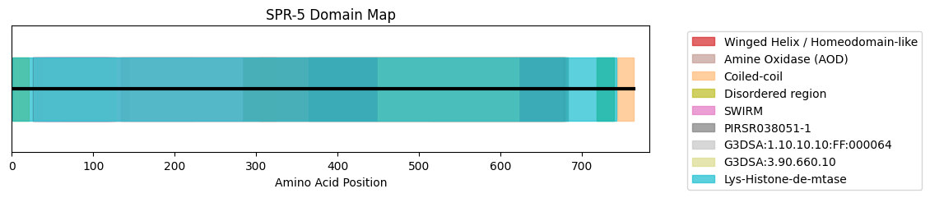
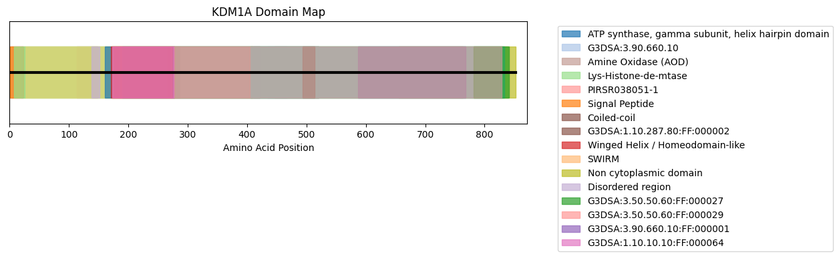
- Occurrences of Shared Domains inSPR-5 vs. KDM1A
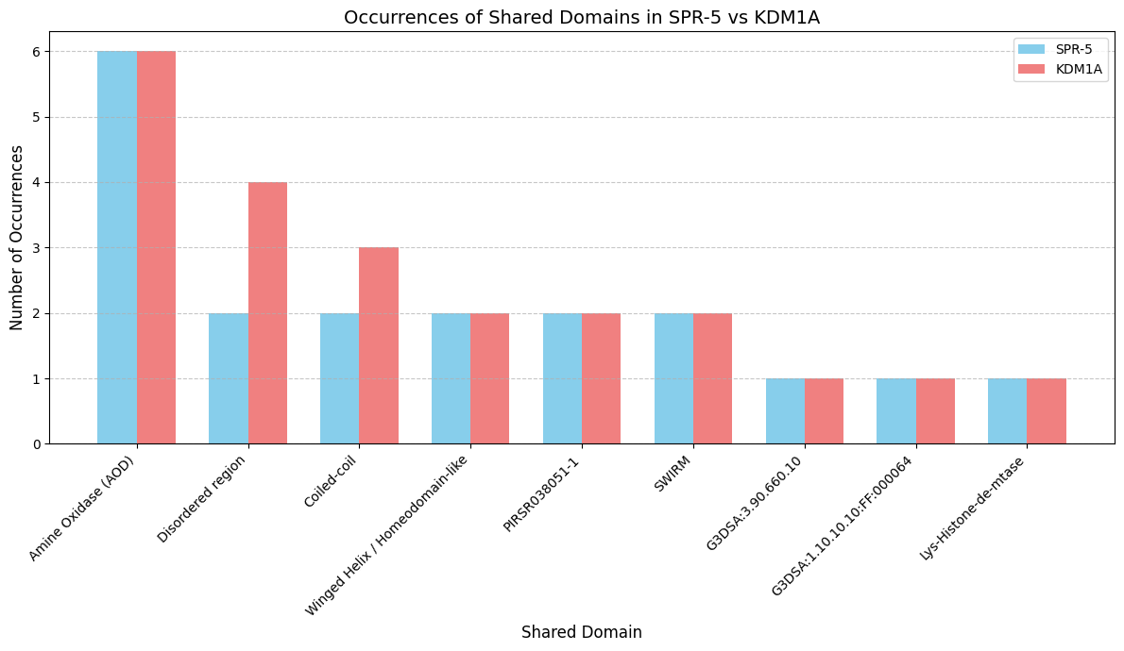

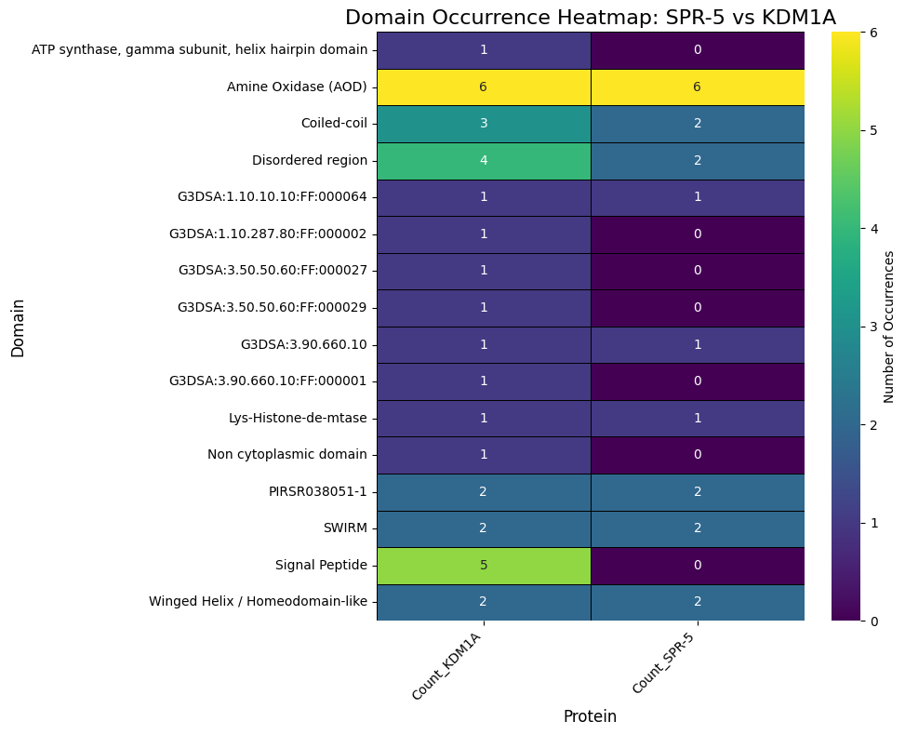

- Domain Occurrence Heat Map

Results to Come: Sequence alignment, Percent identity and similarity within catalytic domains and variant mapping figures
Early Interpretations: The forward and reverse BLAST indicate SPR-5 and KDM1A are reciprocal top hits with modest percent similarity at 28% that spans most of the protein. This suggest that they are conserved orthologs. After domain annotation, shared conserved domains include amine oxidase, disordered regions, coiled-coils, winged helix/homeodomains, SWIRMs, PIRSROs, G3DSA:3 and G3DSA:1 regions. This suggests that protein function (due to conservation of shared catalytic domains) is also conserved.

5. Discussion & Next Steps

Interpret preliminary results/patterns & insights: In context of the research question, BLAST analyses reveal pairwise similarity of 28% and there appears to be many shared catalytic domains among SPR-5 and KDM1A. This conservation supports the use of C.elegans as a model for studying KDM1A-linked fertility and development.

Remaining challenges or issues: Remaining challenges include running the remaining bioinformatic tests smoothly and producing good visualizations that summarize results.

Next steps: Next steps include completing remaining tests, producing figures and results, writing full interpretations/discussion, and creating presentation.

6. Reproducibility & AI Use
When using AI, I will keep a log of AI usage in a GitHub repository and provide the link. This will include what AI was used for, how results were verified, and where prompts and outputs are documented.

Overall GitHub Repo: https://github.com/marlanaswann/spr5-kdm1a-conservation-.git
AI Usage: https://github.com/marlanaswann/spr5-kdm1a-conservation-/blob/main/docs/ai_usage.md

7. References
Dozier, J., Villhauer, M., & Carpenter, B. (2024). Sterility in the offspring of spr-5; met-2 mutants may be caused by inherited H3K4 methylation and altered germline transcription. microPublication biology, 2024, 10.17912/micropub.biology.001365. https://doi.org/10.17912/micropub.biology.001365
Marabelli, C., Marrocco, B., & Mattevi, A. (2016). The growing structural and functional complexity of the LSD1/KDM1A histone demethylase. Current Opinion in Structural Biology, 41, 135–144. https://doi.org/10.1016/j.sbi.2016.07.011
Siklenka, K., Erkek, S., Godmann, M., Lambrot, R., McGraw, S., Lafleur, C., Cohen, T., Xia, J., Suderman, M., Hallett, M., Trasler, J., Peters, A. H., & Kimmins, S. (2015). Disruption of histone methylation in developing sperm impairs offspring health transgenerationally. Science, 350(6261). https://doi.org/10.1126/science.aab2006

